« Future office » challenge by Bouygues Construction

All details may be found at http://futureoffice.matching-up.io/fr/challenges/1?lang=en
Who is Bouygues construction?
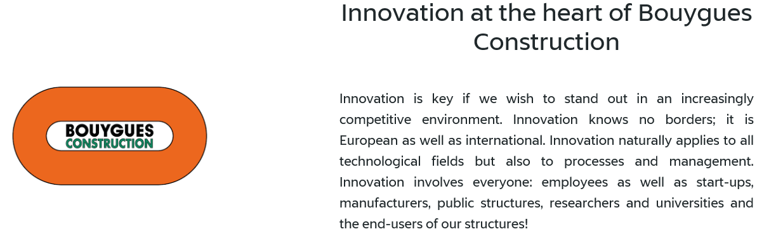
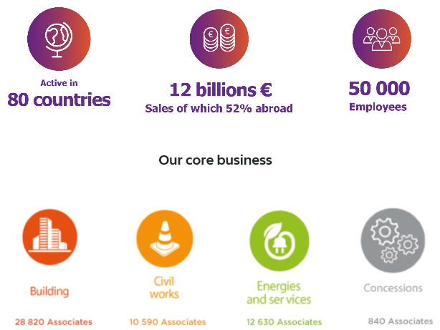
www.bouygues-construction.com

The purpose of the challenge is to detect innovative projects, products, services which could bring value to the Bouygues offer regarding those 8 areas of business:
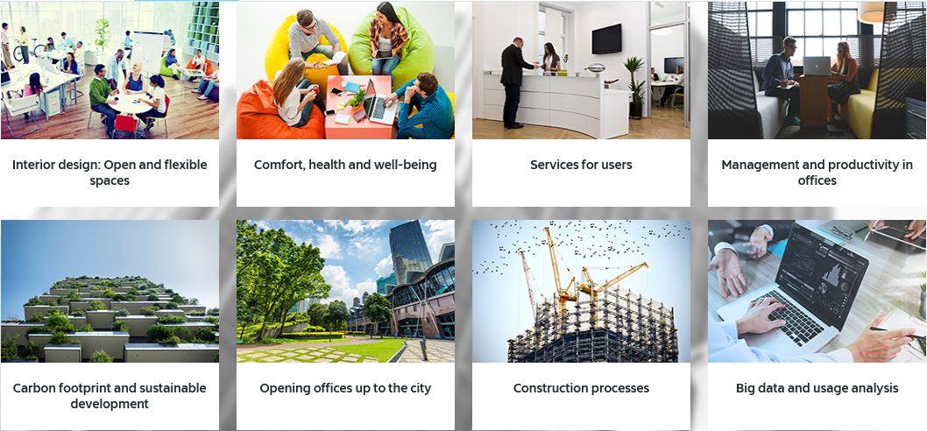

For the startup, being selected and approved in this challenge:
- Has a significant value for other clients, partners, investors etc,
- Can lead to significant sales on various Bouygues projects throughout the world.
Applicants should send their elements no later than September 5th.
Registration will be closed Sunday, September 11th 2016 at midnight (Paris Time).
All documents in English.
From September 12th to October 30th : Selection and matching : startups are evaluated, and the approved list is submitted to all project managers of all Bouygues subsidiairies in the world. All managers have the ability to select 1 startup and become “co-operator” with this startup. Startups which don’t find any “co-operator” will stop here.
From October 30th to November 18th : Collaboration phase : together with the Bouygues co-operator, a final pitch is elaborated. All startups at this stage will be invited to perfom their pitch during an event (date and place to be determined).
Final selection : Among the selected startup, a limited number of them will receive one of these :
- Visibility among all Bouygues Construction employees in search of innovation.
- A place in the “open innovation network” from Bouygues group (which, in addition to Bouygues Construction, is composed of Bouygues Telecom, Bouygues Immobilier and Colas Roadwork)
- Presentation to management of Construction Venture, the investment fund of the group
- R&D support with Bouygues R&D and sales agreement.
Application Form.

Initial application form consist of :
Applicant presentation form (see next page)
Video pitch, in English, less than 1 minute
Powerpoint or pdf presentation
“Executive summary” with all relevant details of the proposal.
All digital files will be in the following formats : DOC/DOCX/PDF/PPT/PPTX/KEY/ODT

Applicant presentation Form
Describe shortly (50 words) your solution:
Why is it innovative?
Why is it interesting for Bouygues Construction?
What is your offer? What do you sell/rent and at what price?
Who are potential customers? (building companies, real estate devloppers, end users, ingenieering companies, contracting authority etc.)
What is your targeted geographical zone?
At which step of development are you? (R&D, prototype, sales…)
What is your last turnover (if any)? (optionnal)
What type of partnerships with major account are you looking for? (choose one)
Co-developpment, direct sales, sales partnership, R&D founding, money raising / joint venture, visibility, other (precise)
Have you ever worked with Bouygues Construction? If yes, name of contact?
Catégory of project. This is intended to valorised your project for internal employees who will watch your application. Name at least one of each list :
Theme :
Interior design : open and flexible spaces / comfort, health and well-being / services for users / management and productivity in offices / Carbon footprint and sustainable development / opening offices up to the city / construction processes / big data and usage analysis.
Phase : in a real estate project cycle, which phase(s) is most relevant for you :
Real estate development / Design / workship / operation / maintenance / services
Operation type : New buildings / renewal of old buildings / operation of buildings.
R&D themes that are close to your activity :
Building Information Modelling / energy performance / new construction mode / construction site equipment + ergonomy / ecofriendly design / engineering, materials / Intelligent building / sustainable town.
Link to your video (youtube, dailymotion, vimeo) under a format like https://youtu.be/A_nqC9xPjYs :

